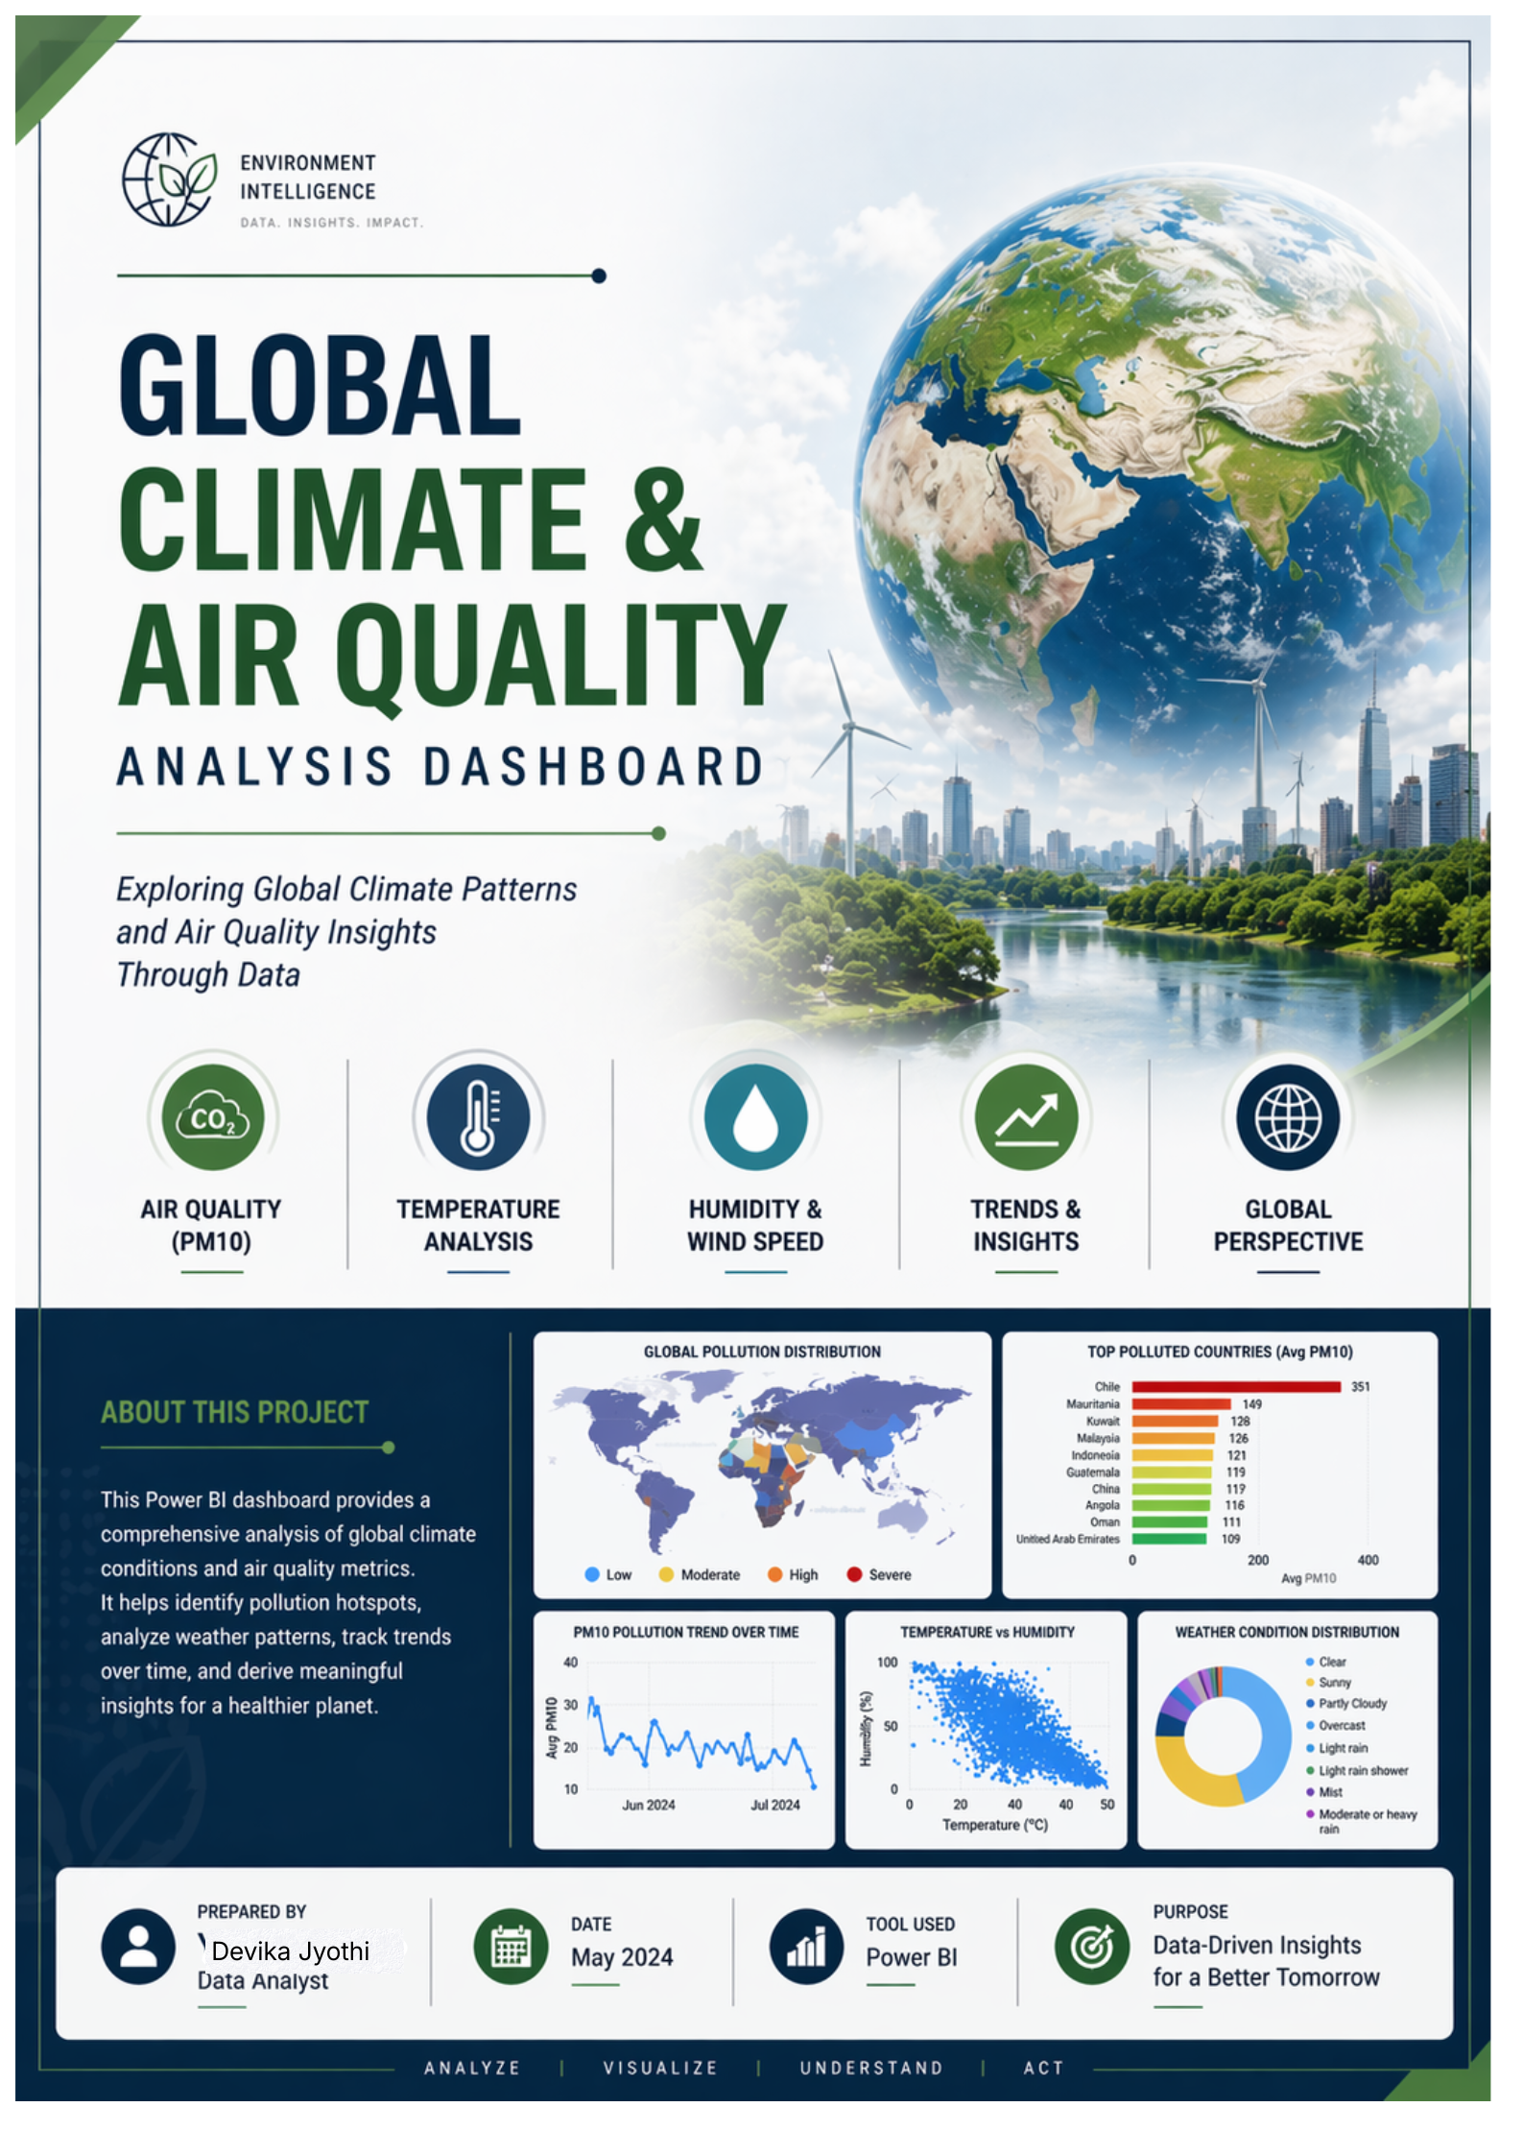

Project Overview
This project analyzes global climate conditions and air quality using Power BI. It focuses on key environmental factors such as temperature, humidity, wind speed, and PM10 (air pollution indicator).
The dashboard helps to:
- Monitor global environmental conditions
- Identify highly polluted countries
- Analyze trends over time
- Support data-driven insights

Objectives
- Analyze air pollution levels (PM10) across countries
- Study climate variables (temperature, humidity, wind speed)
- Identify most polluted countries
- Visualize pollution & temperature trends over time
- Understand relationships between environmental factors

Dataset Description
The dataset contains:
- Country
- Temperature
- Humidity
- Wind Speed
- PM10
- Weather Condition
- Date

Data Import & Exploration Using Python
The dataset was first imported into Python for initial analysis and preprocessing.

🔹 Steps Performed:
- Checked dataset structure using info()
- Generated statistical summary using describe()
- Identified missing values using isnull()
- Detected and removed duplicate records
- Dropped irrelevant/unnecessary columns
- Performed basic exploratory visualizations
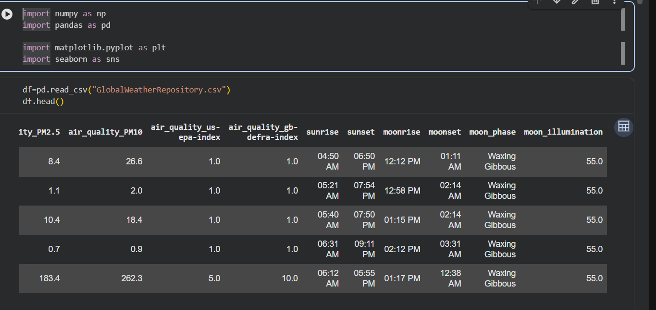
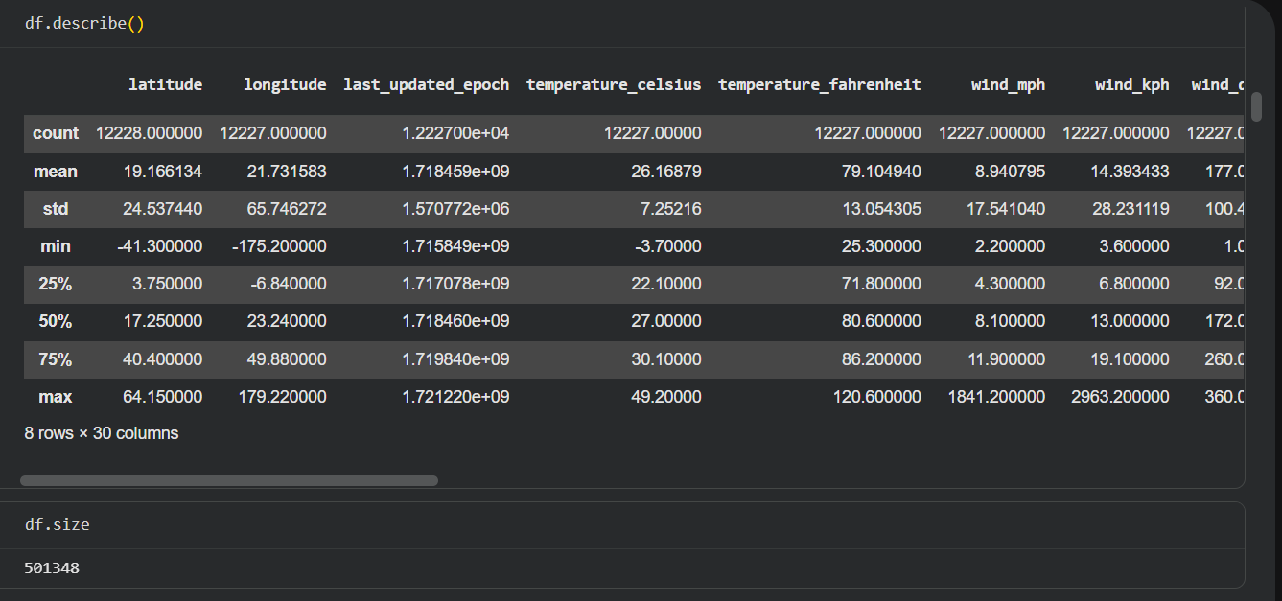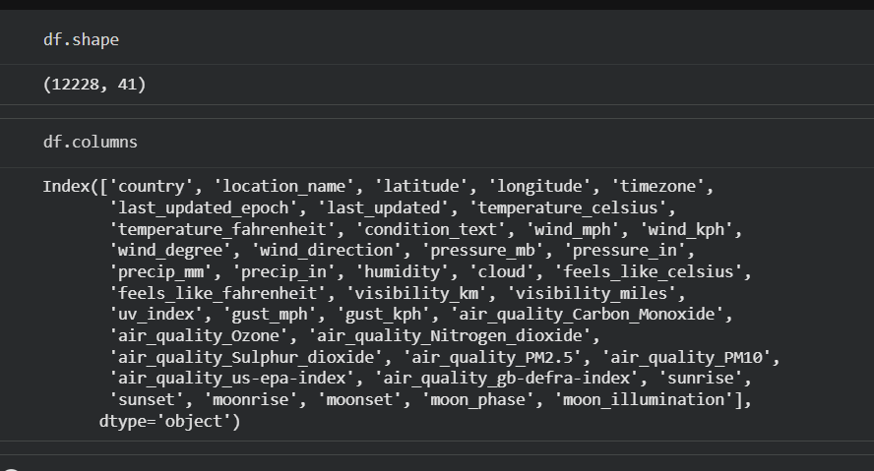

Data Cleaning & Preparation
- Removed duplicate and missing values
- Standardized column formats
- Converted Date into proper format
- Ensured consistent data types for analysis

Data Modeling

🔴 Problem Faced
- Map and bar chart showed different pollution results
- Example: Chile appeared high in one visual and low in another

Solution Implemented

🔹 Created Country Dimension Table
Country Table = DISTINCT('cleaned_weather_data'[Country])

🔹 Relationship Setup
- Country Table[Country] → cleaned_weather_data[Country]
- Type: *One-to-Many (1 → )
- Cross filter: Single

Result
- One unique country per record
- Correct aggregation
- Consistent visuals across dashboard
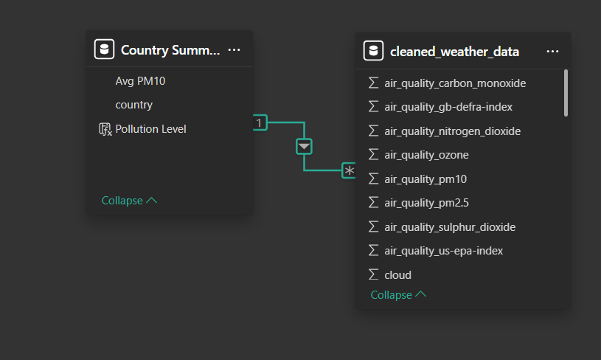
Data Model & Relationship

DAX Calculations

🔹 Average PM10
Avg PM10 = AVERAGE('Table'[PM10])
🔹 Pollution Level Classification
Pollution Level =SWITCH(TRUE(),
[Avg PM10] <= 50, "Low",
[Avg PM10] <= 100, "Moderate",
[Avg PM10] <= 200, "High",
"Severe"
)

Dashboard Components

🔹 KPI Cards
- Average Temperature
- Average Humidity
- Average Wind Speed
- Average PM10
- Maximum Temperature
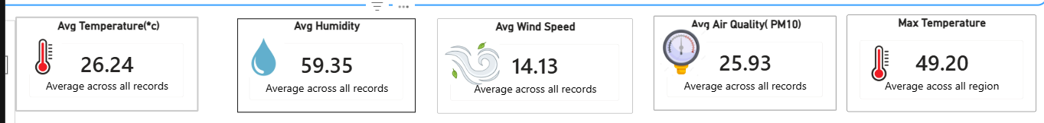

🔹 Visualizations

Filled Maps
- Global Pollution Distribution
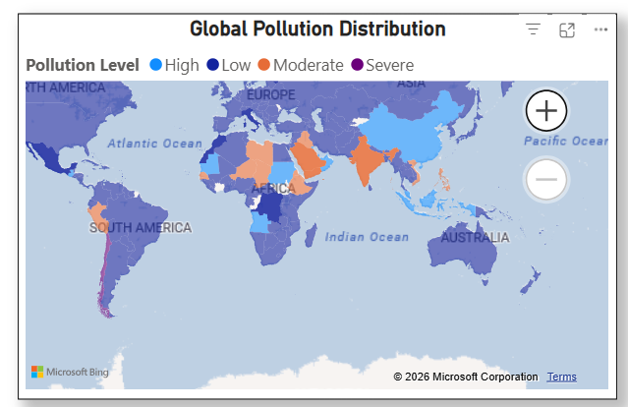

Bar Chart
- Top Polluted Countries
- Based on Avg PM10
- Data labels enabled
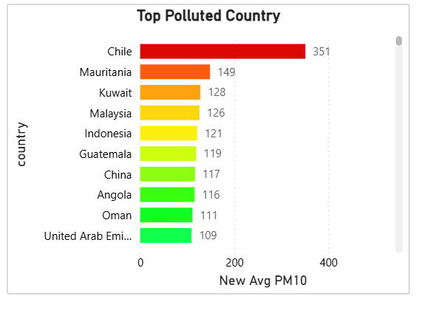

Donut Chart
- Weather Condition Distribution
- Shows percentage of weather types
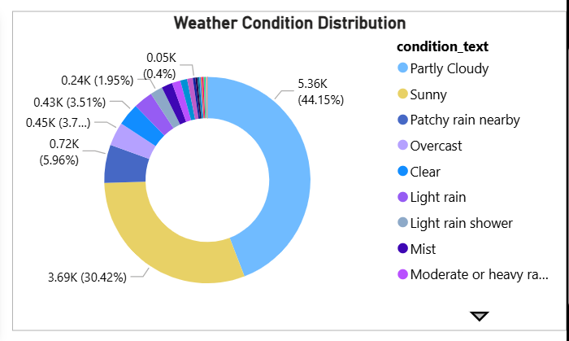

Line Charts
- Global PM10 Pollution Trend Over Time
- Global Temperature Trend Over Time
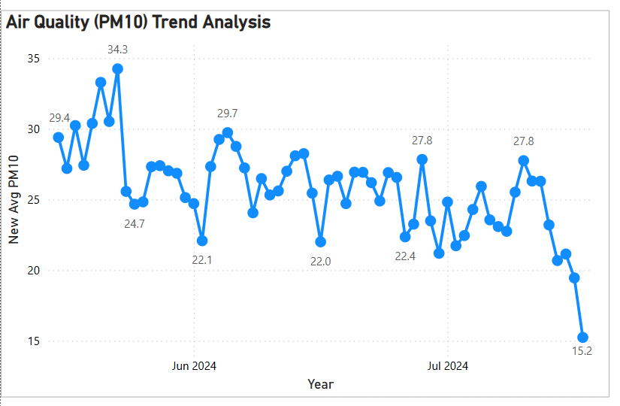
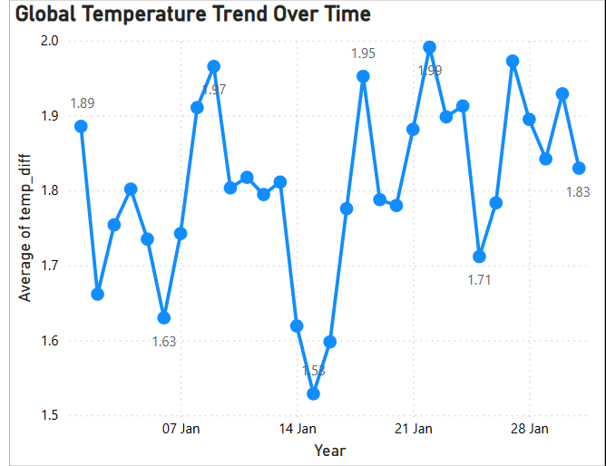

Scatter Plot
- Temperature vs Humidity
- Used to identify correlation
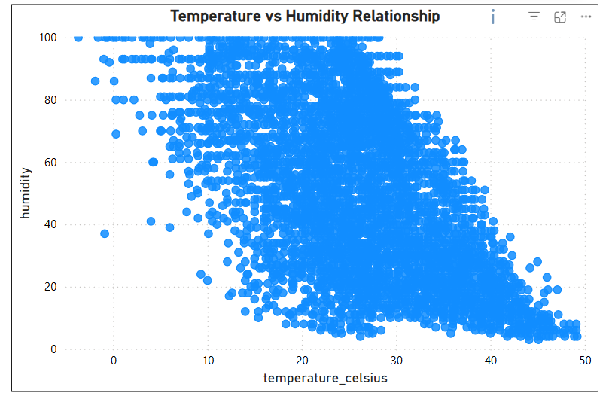

Slicers
- Country
- Weather Condition
- Date
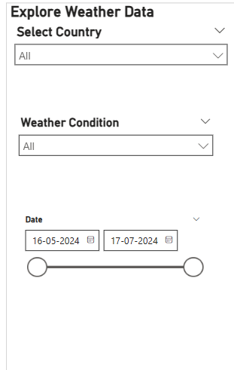

Dashboard Design
- Clean and structured layout
- Consistent color theme:
  - Low
  - Moderate
  - High
  - Severe
- Data labels enabled for clarity
- Interactive filtering between visuals

Key Insights
- Chile is the most polluted country, showing the highest PM10 level.
- Air pollution is decreasing over time, indicating improvement.
- Temperature and humidity show weak correlation.
- Clear weather is the most common condition globally.

Challenges Faced
- Aggregation mismatch (SUM vs AVG)
- Map not supporting “fx” color formatting
- Inconsistent results across visuals
- Confusion in Filled Map fields (no “Values”)

Solutions Implemented
- Used Average PM10 instead of Sum
- Created Pollution Level categories using DAX
- Fixed data model using Country dimension table
- Used Legend for map coloring
- Standardized logic across all visuals

Conclusion
The dashboard effectively presents global environmental insights, helping users understand pollution levels, climate trends, and weather patterns. It ensures accurate and consistent analysis through proper data modeling.

Future Enhancements
- Include PM2.5 and full AQI index
- Add real-time data integration
- Implement forecasting (trend prediction)
- Add drill-through and advanced interactivity

